Yorba Linda High School
Link Crew
Pizza Fundraiser

Tuesday, September 28
11a.m. – 9 p.m.

Lamppost Pizza will donate 25%
of all regularly priced orders when you mention Yorba Linda High School.

Valid on dine-in, take-out and delivery.

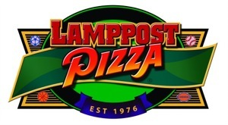

Lamppost Pizza East Yorba Linda
21480 Yorba Linda Blvd (at New River Road)
Albertsons Center
(714)693-9190
www.lamppostpizzaeastyorbalinda.com

